Lots that Dig Holes

This package contains nine one-tile long lots that have been modded to dig holes, and one that does the reverse by lifting the ground level up. Most of the hole digging lots have been designed to dig entrances for tunnels, but they can be used in many ways (digging a trench for a sunken highway, or for an underpass are examples).

New lots in this release are: Hole Digger for Avenue, Deeper Hole Digger for Rail, Deeper Hole Digger for Road, Deeper Hole Digger for Monorail, and Hole Digger for Sunken. The Ground Lifter Lot has been changed.

Installing these Lots

To install these lots, place them in your Simcity plugin directory. Each lot is independent, so you can save menu clutter by placing only some of the lots in the plugin directory. The lots will be available near the end of your Simcity Transport Misc. menu.

There are no known conflicts with these lots.

For any questions or problems you can PM me (smoncrie) at simtropolis or post to the 'My Experiment in tunneling' thread at Simtropolis:
http://www.simtropolis.com/idealbb/view.asp?mode=viewtopic&topicID=44972&num=30&pageNo=4

These lots are provided as is, Simtropolis, Maxis and I are not responsible for any unintended damage.

Using these Lots

Dragging the correct transit (rail, road, highway, etc.) over the lot activates it. Dragging over the entire lot moves the entire tile down (or up), dragging over one side moves that side down (or up).
More detailed Instructions on the use of these lots are included further down in this document. See:
Using Hole Digging Lots to Make Tunnels
Creating Sunken Highways
Rail and Ground Highway Crossing a Sunken Highway
Road and Avenue Crossing a Sunken Highway

These lots do not create smoothly slopping access ramps, but they are improved if you use BRF's BRF_TunnelSlopeMod-b mod. You can find this mod attached to a post at:
http://www.simtropolis.com/idealbb/view.asp?mode=viewtopic&topicID=44972&num=30&pageNo=3
(I had the wrong mod specified in the last version. Sorry!) BRF's mod is optional; it is not required. BRF's mod was not installed when the pictures in this document were created.

Note: BRF's mod allows you to create shallow tunnels. Such tunnels should be used with care. I have seen collisions between a train in a shallow tunnel (underground), and a car on a surface road above!

Lot Descriptions

Hole Digger for Rail, 8m Drag rail tracks to dig a hole for a rail tunnel.

Deeper Hole Digger for Rail, 10m* Drag rail tracks to dig a hole for a rail tunnel.
Designed to work on more uneven ground.

Hole Digger for ground highway, 12m Drag a ground highway to dig a hole for a ground
highway tunnel.

Hole Digger for avenue, 14m* Drag an avenue to dig a hole for an avenue tunnel.

Hole Digger for road, 14m Drag a road to dig a hole for a road tunnel, or a one-way
road tunnel.

Deeper Hole Digger for road, 17m* Drag a road to dig a hole for a road tunnel, or a one-way
road tunnel. Designed to work on more uneven ground.

Hole Digger for monorail, 23m Drag a road to dig a hole for a monorail tunnel, then
bulldoze the road. (Monorail tracks can not be used in
the initial dragging because they do not work for such
a deep hole.) This lot may not work if you are too close
to your city's sea level.

Deeper Hole Digger for monorail, 26m* Drag a road to dig a hole for a monorail tunnel, then
bulldoze the road. This lot is the same as the Hole
Digger for monorail, except that it is designed to work
on more uneven ground.

Hole Digger for sunken, 15m* Drag a road to dig sunken transit (e.g. highway).
This lot is designed sink the tops of elevated highways
and overpasses down to ground level.

Ground Lifter, 15m Drag a road to lift the ground to the same level as the
tops of elevated highways and overpasses.
Note: Both the height and the transit type have been
changed in this release.

* New lot with this release

To make them look different, the deeper hole diggers all have a second yellow Digger Prop.
It was not possible to make deeper hole digger lots for avenues and Ground Highways.

I hope you find this package useful.

I thank simtropolis and dirk for a great web site, and ilive for his reader.

smoncrie

Using Hole Digging Lots To Make Tunnels

Make sure the ground is nearly flat where the tunnel entrance will be, or the tunnel may not be available (more below). The picture below shows how to flatten the ground using single tile streets. If you use the 'deeper' hole digging lots you may be able to skip this step.

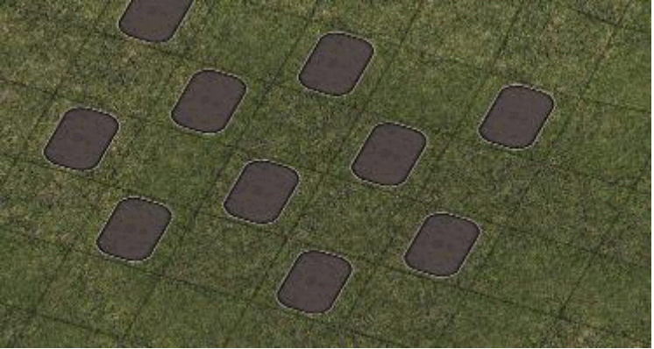

Each kind of hole digging lot requires a specific transit type (rail, road, avenue, etc.) dragged over it to cause it to dig.

Note that the monorail lots are unusual; they require the dragging of a road to dig a hole. After the holes are made, the monorail tunnel is made by dragging monorail tacks (not a road).

In the following example we use the avenue lot, which requires an avenue to be dragged over it.

Plop the hole digging lot where you want the tunnel entrance to be.

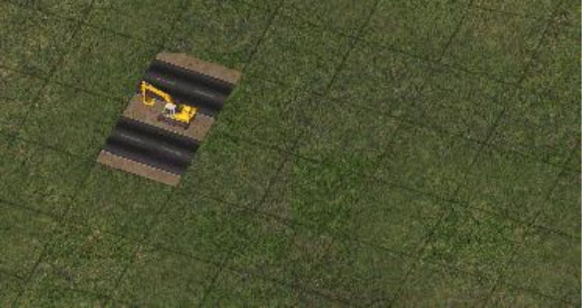

Drag an avenue, starting at the hole digging lot, and ending several tiles away from where the tunnel will be. This will create the hole.

The path may turn red when you are dragging over a hole digging lot. This happens when:
You are dragging the wrong transit type for that lot.
The ground is too uneven (different lots vary in their tolerance for uneven ground).
The bottom of the hole would be below sea level.
In any case the hole digging will fail.

After you drag the avenue, it should look like this:

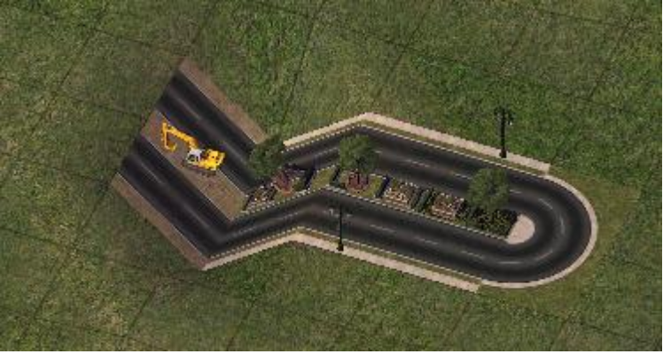

Now bulldoze the hole digging lot to make room for the tunnel entrance. (For the monorail digging lot the road dragged over the lot also needs to be bulldozed.)

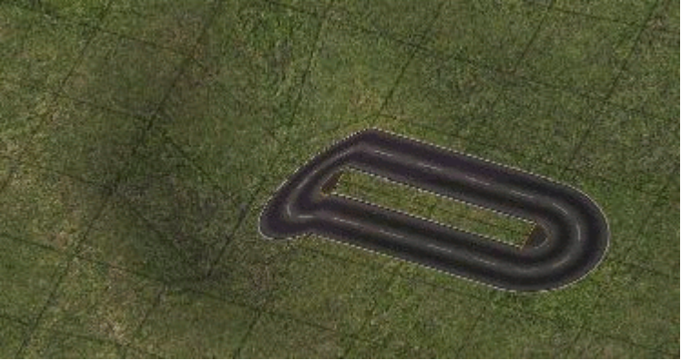

And do all the above steps for the other end of the tunnel...

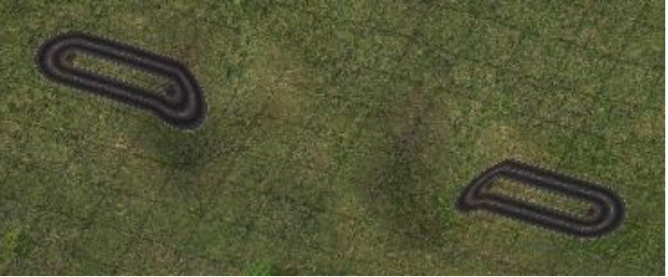

To create the tunnel, drag an avenue over both holes. The location of the tunnel will show in green. If it does not show in green, cancel the drag. Try dragging in the opposite direction. If that does not work you need to dig the holes a little deeper, or to start over. The most likely reason for it to not work is that the hole entrances were not flat enough when you started. If it starts showing green, but stops before the second hole is reached (not uncommon in longer tunnels) you will need to shape the ground between the holes. The ground must not sag below the direct line between the two holes. Sometimes even a single tile dip will create problems. This problem can be prevented if everything starts level (the location of both holes and the ground between them).

Note that the type of transit you drag to create the tunnel should match the type of digging lot used (e.g. if it's monorail; drag monorail).

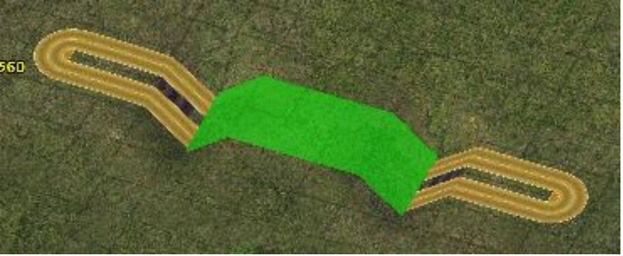

The final result is shown below.

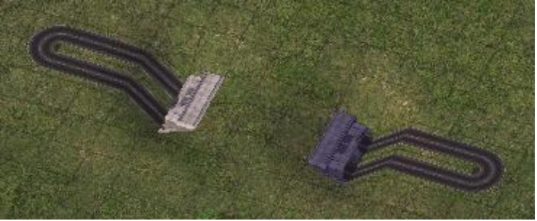

Creating Sunken Highways

In this example we will use the Hole Digging lot for Sunken because it can have better looking overpasses.

Plop the Hole Digging Lot for Sunken on every other tile, in a line.

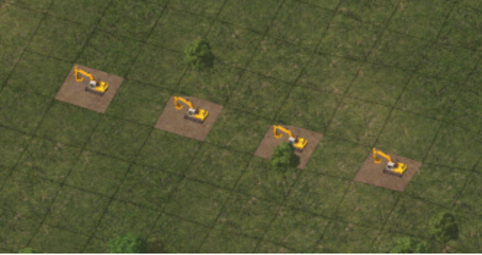

Drag a road over all the lots to create the trench.

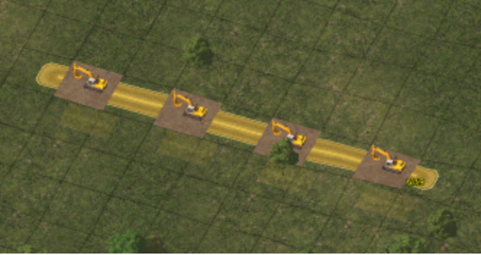

Drag a second road next to and parallel to the first to widen the trench.

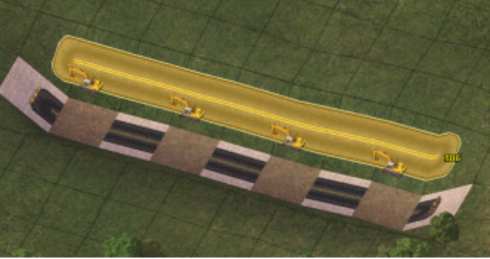

Bulldoze the hole digging lots and the roads, and create a ground highway in the trench.

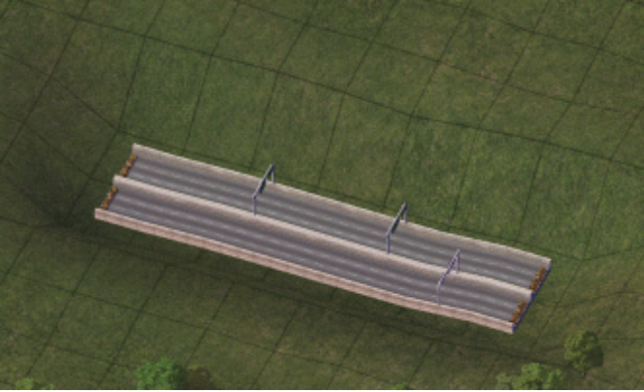

A raised highway can be created using exactly the same steps, but with the Ground Lifter Lot in place of the Hole Digging Lot for Sunken.

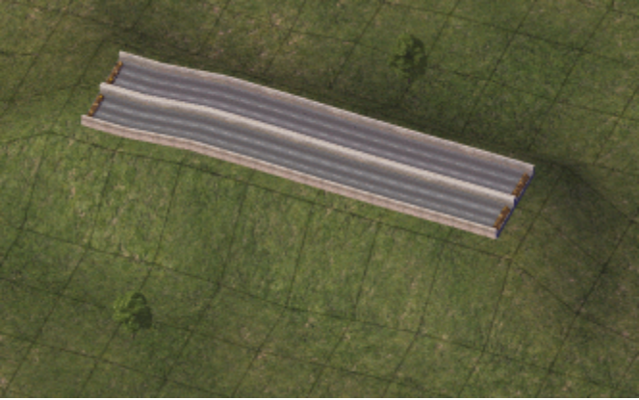

Rail and Ground Highway Crossing a Sunken Highway

To create the crossing, simply drag the rail, or ground highway across a sunken highway (created in the way described previously) until the path turns blue. Then release the mouse button to create the crossing.

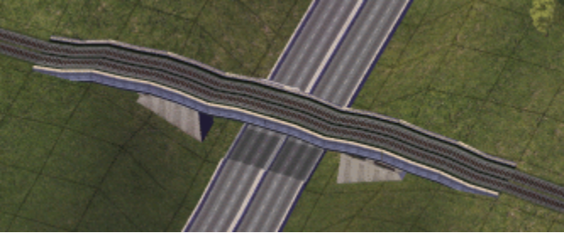

The crossing is a bit bumpy, but I do not know of any way to make it better.

Notes:
The Simtropolis Network Addon Mod must be installed to get the rail crossing shown here.
BRF's BRF_TunnelSlopeMod-b mod causes overpasses to push the banks down, so the result is different than shown.

Road and Avenue Crossing a Sunken Highway

This section assumes that BRF's BRF_TunnelSlopeMod-b mod has not been installed.

In the place where the road or avenue will cross, plop the new Deeper Hole Digging Lot for Rail on either side of the sunken ground highway (created in the way described previously) at a distance of one tile.

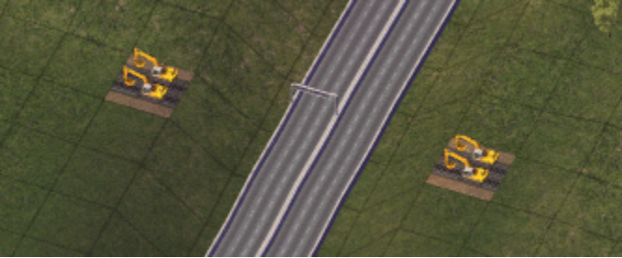

Add rail tracks between the highway and the hole digging lots.

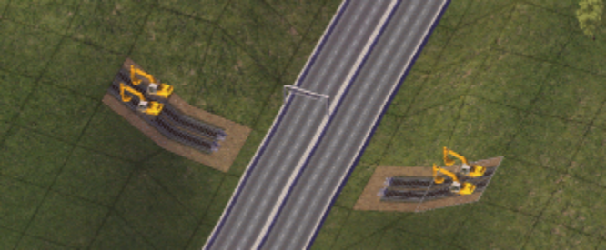

Bulldoze the hole digging lots and create a new 3-tile section of rail track on each side. If you are making an avenue crossing, a second set of tracks should be created next to and parallel to the first.

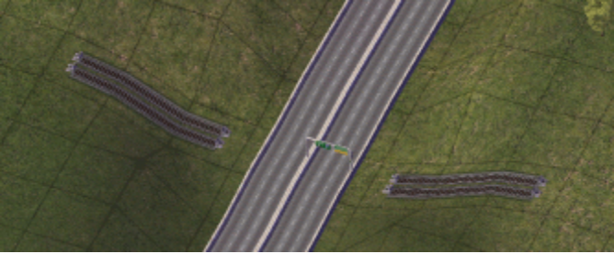

Bulldoze the rail tracks, and drag the road or avenue across the sunken highway. Release the mouse button when the path turns blue.

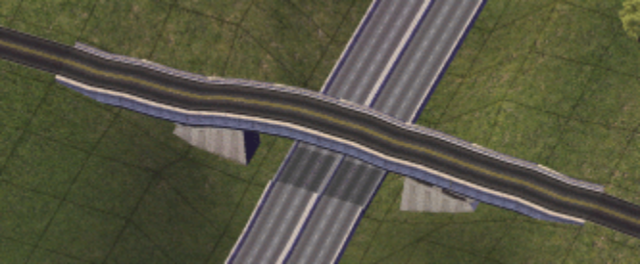

The crossing is a bit bumpy, but I do not know of any way to make it better.

